Step 1

Use blaze meter application to record the actions in the website .

After recording the action from the website ,save the file as jmeter file

Step 2

Open the jmeter application

Create the name for the test as lesson end project

After that upload the jmeter file as previously recorded jmeter file

Step 3

Create the **view result tree** using thread group→add→listeners→**view result tree**

Create the **simple data writer** using thread group→add→listeners→ **simple data writer**

Create the **summary report** using thread group→add→listeners→ **summary report**

Create the **uniform random timer** using thread group→add→timer→**uniform random**

**Timer (**Random delay seconds as 500 milliseconds**)**

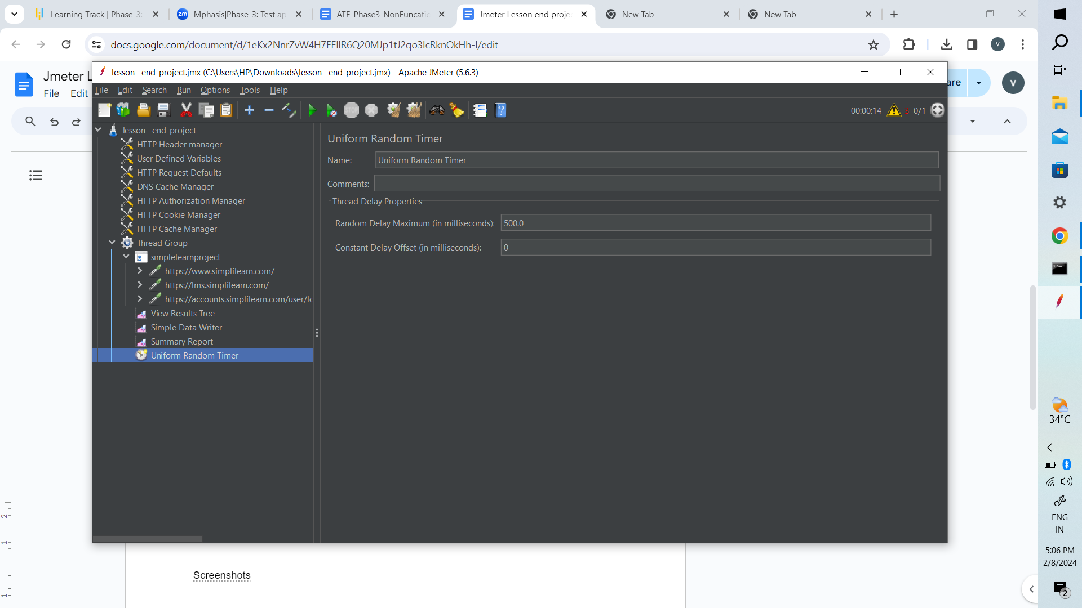

Step 4

Run as remote server(**192.168.1.35**) to run below jmeter

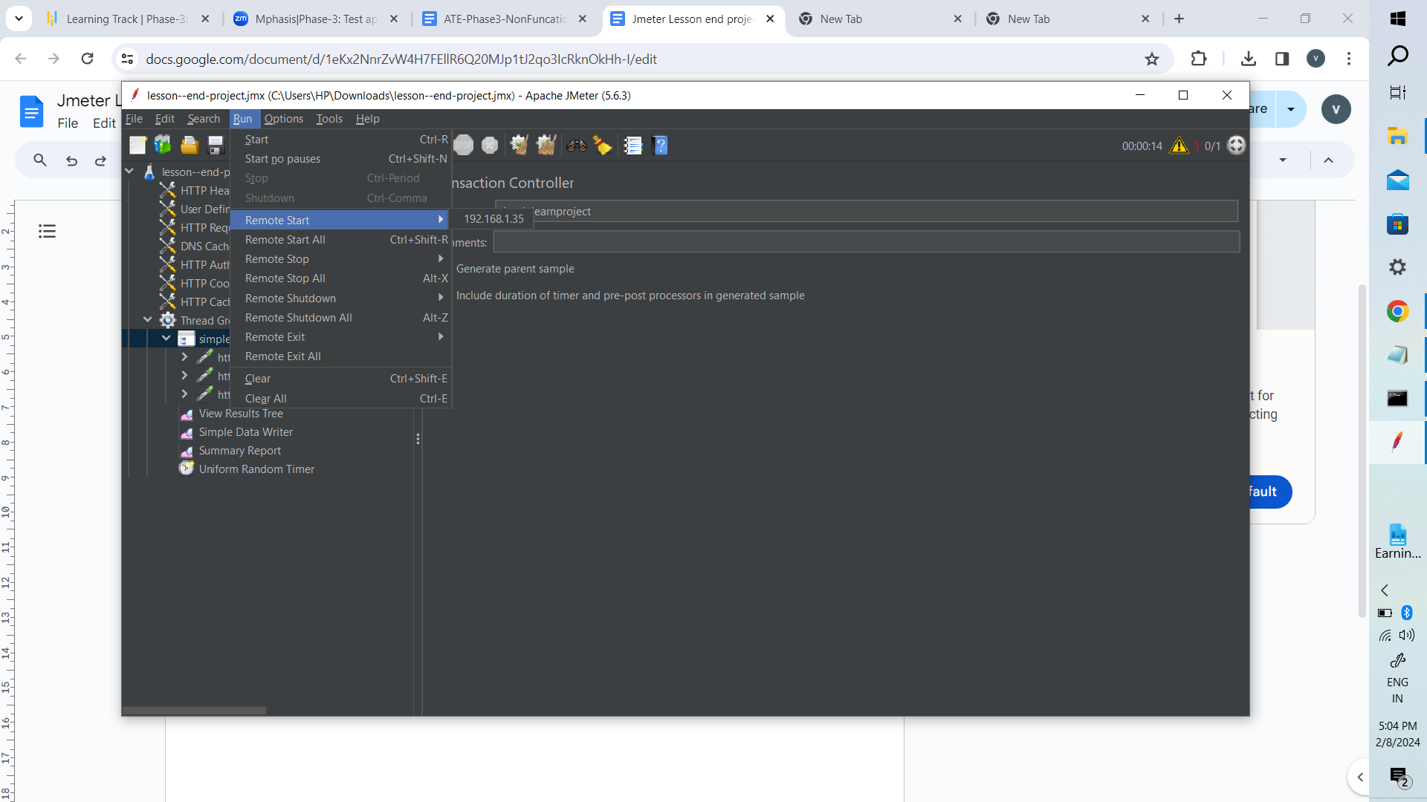

Screenshots

